

**CMP6200**

**Individual Undergraduate Project (FYP)**

**Final Progress Review**

New Ways to Play: A Study in Alternative Game Controllers

**Student Name:** Mamud Rostam

**Student ID:** 23149743

**Course:** BSc (hons) Computer Game Technology

**Supervisor:** Richard Davies

**Reporting Period:** 03/11/2025 to 27/02/2026

**1.0 Log of Completed Activities & Milestones**

Completed several meetings with the supervisor, discussions on how to improve the project, if the modules for the controller will work well together and how to get it working in unity. Gantt Chart updated as well as the kanban board in GitHub to keep track of the progress.

**Key tasks completed during this period include:**

* **Purchased a microcontroller board (Raspberry Pi Pico W) using Thonny a free python tool to allow the Pico to send data to unity and read it as a controller system.**

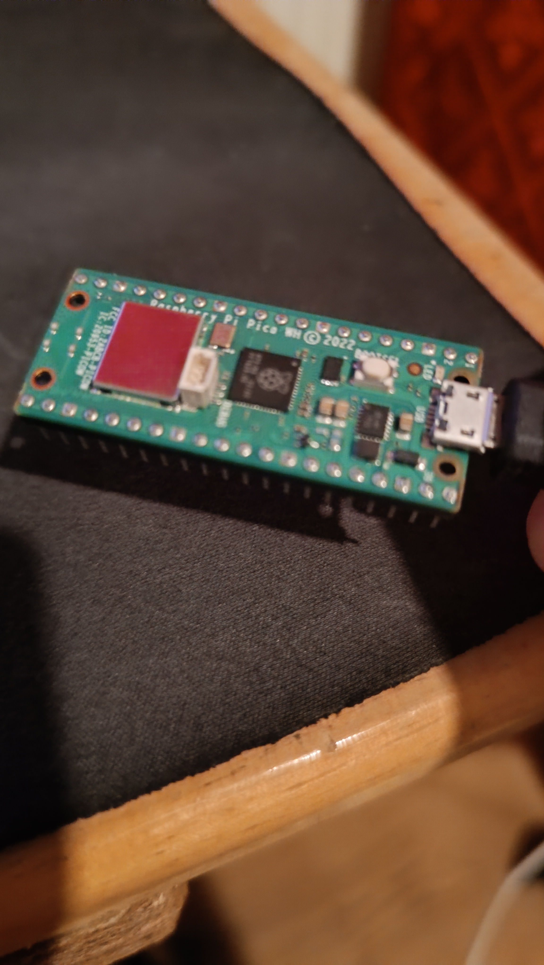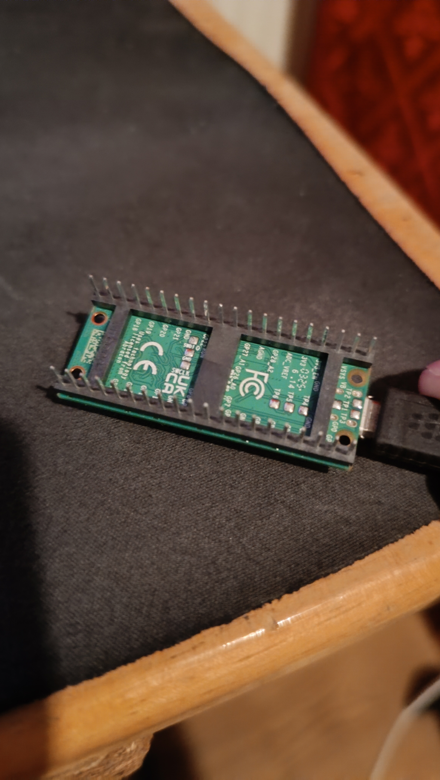

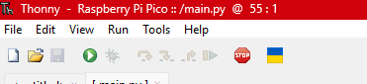



* **Developed a functional FPS game that reads input systems, has a Main Menu, Game Scene and Training room as well as AI enemies using State Machine.**

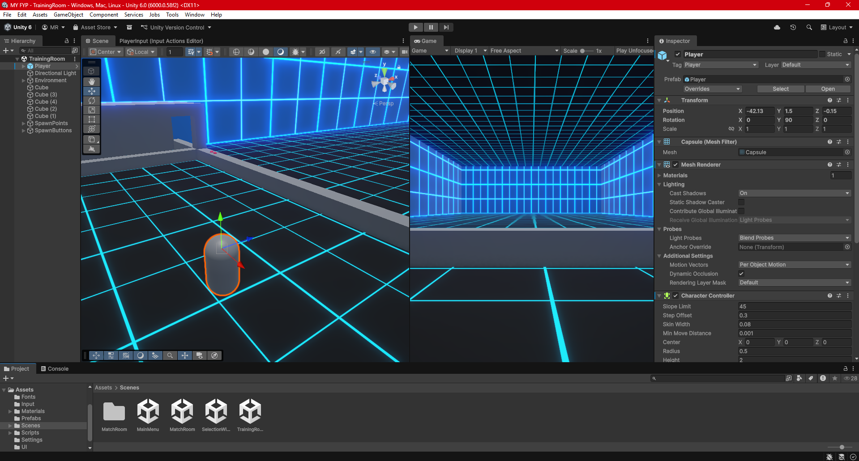

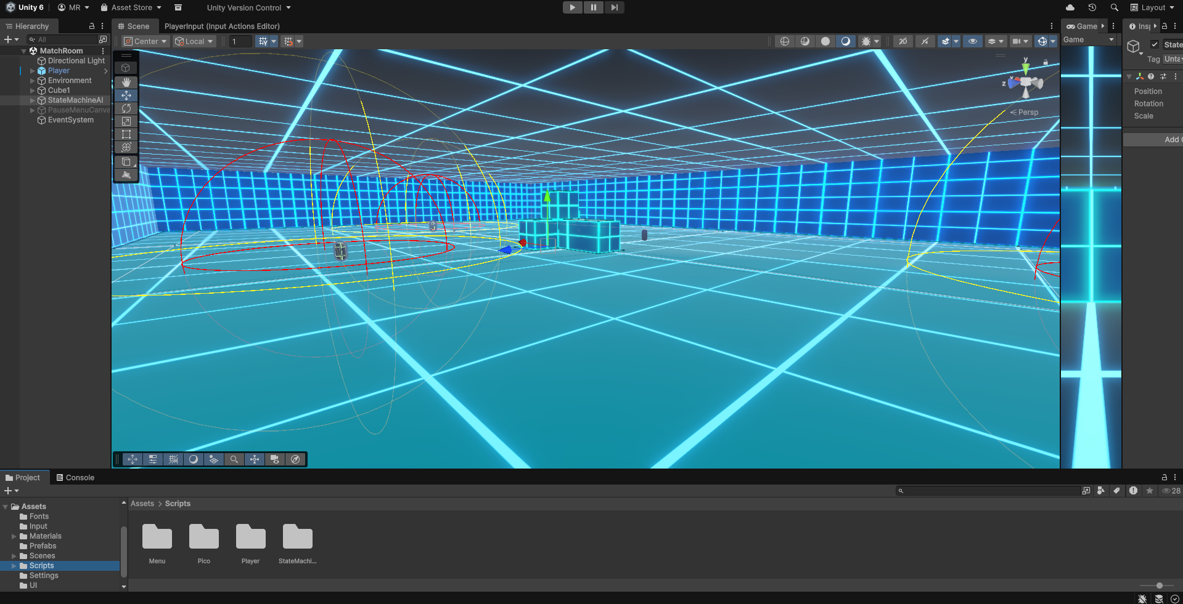

**2.0 Reflection and Iteration**

Not being sure which parts to order but having conversations with my supervisor allows for better understanding of the scope and being able to discuss if the controller can be improved.

Using Thonny for python to script the Pi Pico W H, creating a simple script that allows the microcontroller board to connect via WI-FI to send data to Unity. Would need to change this later maybe to Serial Numbers - Unique ID as it allows for the controller to be used anywhere not just limited to one network.

**2.1 Progress Against Original Timeline**

Currently the progress against the original timeline is good, the game is being made well, and the controller is coming along currently its more on track rather than behind or Infront of the original timeline. The kanban is being updated as work is being done

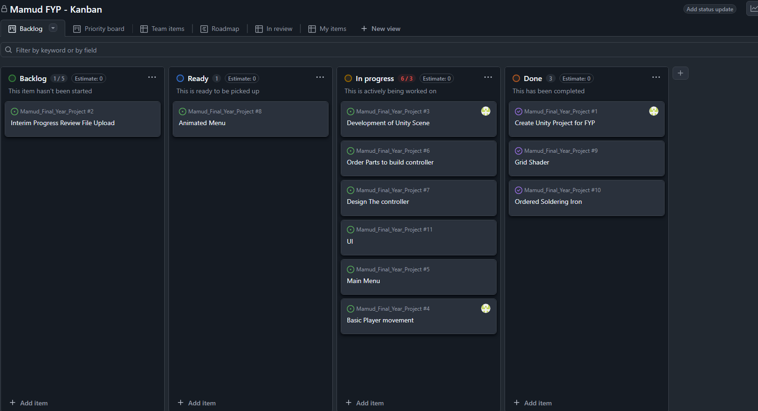

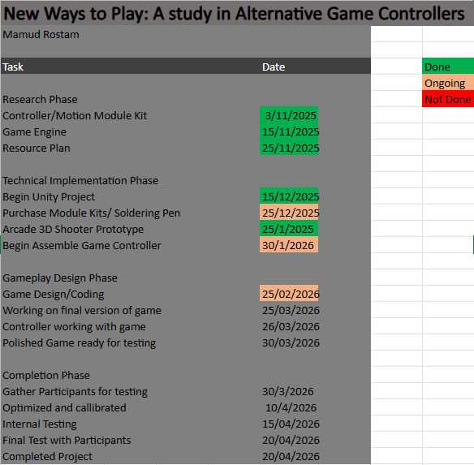

**Updated Gantt Chart of the project timeline**

**2.2 Challenges Encountered & Resolutions**

|  |  |  |
| --- | --- | --- |
| **Challenge Encountered** | **Impact on Project** | **Action Taken / Planned Solution** |
| Not sure which microcontroller board to get. | Project delayed by a lot because of holding back on purchases. | Regular meetings with supervisor helped identify appropriate module kits ended up getting the Raspberry Pi Pico W and using python in Thonny to ensure unity reads the board. |
| Underestimated project timeline due to other commitments. | Risk of project falling behind schedule. | Created a simple project timeline to track progress. |
| Limited experience with controller hardware. | Slower development and increase trial and error. | Review documentation, tutorials and help from supervisor to complete implementation. |

**3.0 Action Plan: Goals for Next Period**

**Key objectives to be met by 29th January 2026:**

* purchased the controller module kits and soldering pen.
* Prototype of the controller and Unity Game Scene Complete
* Ready for simple testing both the controller and game should work seemingly together.

These were the tasks that were supposed to be completed by the 29th January 2026. So far there is a fully functioning game that would work with any input system. The soldering pen has arrived, and the microcontroller board (Raspberry Pi Pico W H) is now compatible with unity.